Math 8 Dawe
Name: ________________________

Chapter 3 - Percents

Test Date: ________________________________________

To do:

3.1 – Percents, Decimals, Fractions
- Complete Notes ⃝

3.2 – Percent Problems
- Complete Notes ⃝

Assignments
- Chapter Assignment ⃝
- Puzzle Booklet ⃝
- Practice Quiz ⃝

Write Unit Test ⃝

Math 8 Lesson 3.1 – Percents, Decimals, Fractions Dawe

A percent is a value calculated ___________________________________, meaning 100% is a whole amount.
For example:
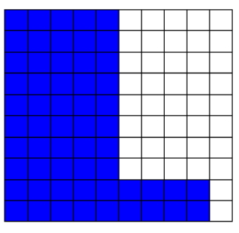
Percents to Decimals
Divide the number in front of the % symbol by 100. This will move a decimal two positions left.
$78\%$ $6\%$ $115\%$

Decimals to Percents
Multiply the number by 100. This will move a decimal two positions right. Don’t forget to include your % symbol.
$0.43$ $2.57$ $0.03$

Percents to Fractions
Make the number in front of the % symbol a numerator with a denominator of 100, then reduce the fraction to lowest terms.
$17\%$ $46.8\%$ $175\%$

Fractions to Percents
Divide the numerator by the denominator, then multiply the value by 100. Don’t forget to include a % symbol.
$\frac{5}{6}$ $4\frac{8}{9}$ $\frac{3}{4}$

Math 8 Lesson 3.2 – Percent Problems Dawe

In order to determine and solve a percentage problem, setting up a _____________________ using equivalent ratios works the best.

$$\frac{portion}{total}=\frac{portion}{total}$$

In all cases, an unknown value in the proportion should occur, where the unknown value is in the proportion changes. Hence the approach to solving the proportion changes.

Examples:
What number is 37% of 52?

40 is what percent of 75?

25% of what number is 16?

Some problems are looking to either increase or decrease a value by a certain percentage.

When it comes to increasing, you must add___________________ to the percentage given in order to increase the overall total.

For decreasing, you may need to subtract the percentage given from ______________________ in order to find the remaining amount after the decrease.

Examples:
15% increase of a monthly salary of $5400. What is the new salary?

20% off a jacket from the original price of $135. What is the new price?

