Math 8 Dawe
Name: ________________________

Chapter 5 – Graphing and Tables

Test Date: ________________________________________

To do:

5.1/5.2 – Graph Types/Graphs and Spreadsheets
- Complete Notes ⃝

5.3 – Cartesian Coordinates
- Complete Notes ⃝
- Quiz 1 ⃝

5.4 – Data Trends
- Complete Notes ⃝

5.5 – Equations, Tables and Graphs
- Complete Notes ⃝

5.6 – Best Form
- Quiz 2 ⃝

Chapter Assignment Handout ⃝

Write Unit Test ⃝

Math 8 Lesson 5.1/5.2 – Graph Types/Graphs and Spreadsheets Dawe

Line Graphs

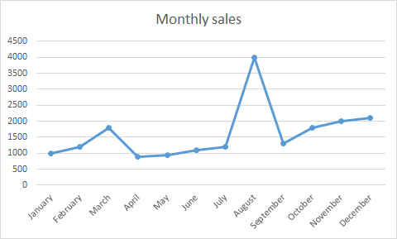

Scatterplots
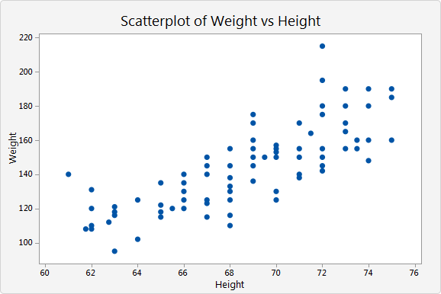

Pie Graphs
Bar Graphs

Pictographs

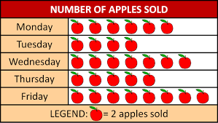

Misleading Graphs

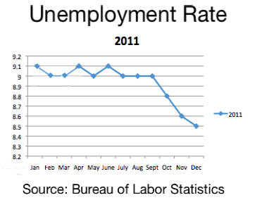

Math 8 Lesson 5.3 – Cartesian Coordinates Dawe

Steps for building a Coordinate Plane:
- Start by thinking about the horizon, then draw our horizontal axis.
- Mark an X on our horizontal axis so we know that it's our X-axis.
- Draw our vertical axis, perpendicular to the X-axis.
- Mark a Y on the vertical axis so we know that it's our Y-axis.
- Confirm Y has a little V in it. Use this to ensure you have the X and Y correct.
- The origin is the intersection point in the middle (where both axes are at zero).
- Add a scale to the X-axis. Positive to the right, Negative to the left.
- Add a scale to the Y-axis. Positive going up, Negative going down.
- You're ready to graph!

Plotting points:
- The location of a point is determined by its coordinates.
- We need an x-coordinate and a y-coordinate.
- The coordinates are often presented like this (1, -2).
- The set of coordinates can also be called an ordered pair.
- The first number is the X-value (left or right).
- The second number is the Y-value (up or down).
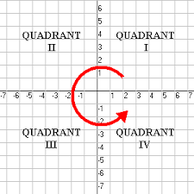

Math 8 Lesson 5.4 – Data Trends Dawe

Types of trends:
- Linear = best represented by a straight line.
- Nonlinear = best represented by some nonlinear curve.

How good is a trend line? Some data follows a trend closely, while other data is not that close. How do we describe the difference?

Correlation Coefficient:
- r = correlation coefficient = how well the curve fits the data
- r = 1: perfect positive correlation
- r = 0: no correlation
- r = -1: perfect negative correlation

Sometimes we want to estimate a value that goes beyond the values that we already know from the pattern. This process of going beyond is called ________________________________.
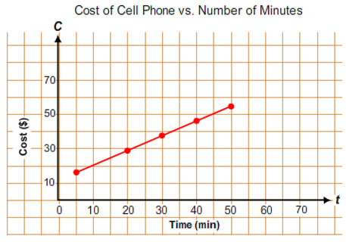
What is the approximate value of the C-coordinate when $t=55$?

Sometimes we want to find a value by calculating or estimating between two already known values; this process is called ________________________________________.
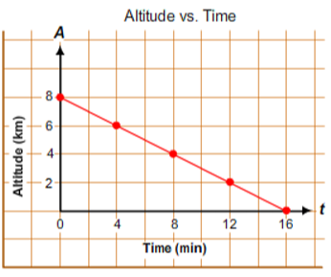
What is the approximate value of the t-coordinate when $A=3$ ?

Math 8 Lesson 5.5 – Equations, Tables, and Graphs Dawe

When data from two variables are collected it is usually put into a table of values and/or a graph, so a relationship between the variables can be more easily recognized.
We will be looking at linear relationships, which means the relationship between the two variables will be _______________.

Equations to tables:
- make table
- sample set of data for independent variable in left column
- evaluate for each set of data in right column
- done!

Tables to graphs:
- make grid
- independent variable on horizontal axis
- dependent variable on vertical axis
- plot each "data set" or "ordered pair"
- done!

To create an equation from a table of values, you need to determine:
- the pattern (When x increases by 1, y increases/decreases by ___ )
- the value of y when x = 0.
Next, input this information into your linear equation as follows:
- the pattern becomes the coefficient for x (the number by which x will be multiplied) Ex. y = 3x + 2
- the value of y when x = 0 becomes the constant (the number added at the end) Ex. y = 3x + 2
Examples:
- Write a linear equation that represents the pattern found in the given table of values and then verify the equation:
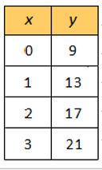

- Complete the table of values for the following graph:
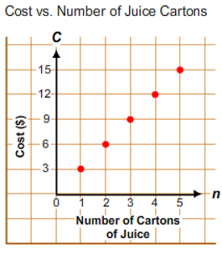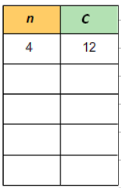

- Graph the following linear equation: $y=2x+1$
