**AWM 11 – Unit 1 – Quiz 2 16**

1) How many students are represented on this graph? *(1 mark)*

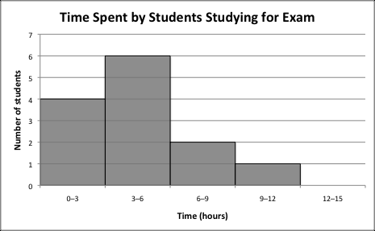

Answer:_____________________________

2) How many students studies for 6 hours or less? *(1 mark)*



Answer:_____________________________

3) Which of the following graphs shows that about 8 respondents were over the age of 65? Circle the graph of your choice. *(1 mark)*

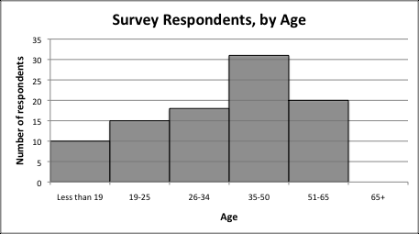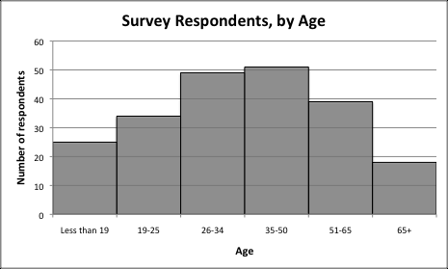

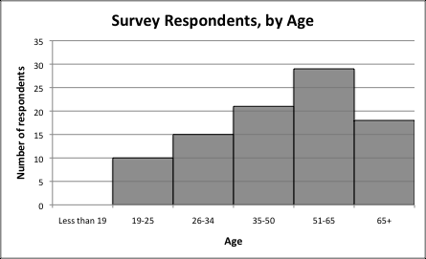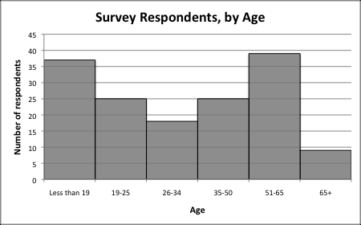

4) Look at the following graph. ***It is misleading***. Why? *(2 marks)*

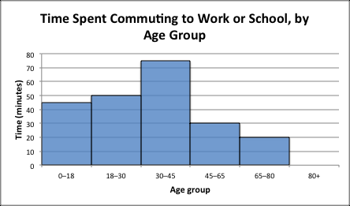

______________________________________________________________________

______________________________________________________________________

______________________________________________________________________

5) In a class of 120 graduating students, 30 would like to have their graduation dinner at a hotel. What percentage of students is this? *(1 mark)*

A) 2.5% B) 23.6% C) 25% D) 32.5%

6) On a circle graph, how many degrees of the circle are measured for a category worth 34%? *(1 mark)*

A) 1150 B) 1220 C) 1250 D) 1370

7) In the graph below showing attendance at a music festival over 6 years, which year had the lowest attendance? *(1 mark)*



Answer: ________________________________

8) Look at the following graph. ***It is not misleading***. Why? *(2 marks)*



Method of Transportation Used by

Students to Get to School

______________________________________________________________________

______________________________________________________________________

______________________________________________________________________

9) Max is making a circle graph of his spending on various items. How many degrees would be used to represent each of the following expenses? Show your work!

*(4 marks)*

|  |  |
| --- | --- |
| **Expense** | **Amount spent** |
| **Rent** | **$900.00** |
| **Food** | **$860.00** |
| **Entertainment** | **$770.00** |
| **Clothes** | **$320.00** |

10) A business is tracking how people decide to shop at their store. It finds that 13% of its customers make a purchase on impulse after browsing through the store. If they have 750 customers in one month, how many customers made impulse buys?

*(2 marks)*